2013
Jonathan Knight
UNT
7/3/2013
Notepad++ User Manual

Table of Contents

Table of Contents iii
Introduction v
Installation and Configuration of Notepad++ 3
NppFTP File System 9
Features and Usage 13
Index 25

Introduction
My name is Jonathan Knight I am a student at the University of North Texas and majoring in computer science. The courses that I have to take require the use of a text editor to create the programs. However the courses do not recommend a particular one. Notepad++ is a powerful text editor and can make programming much simpler. This manual will cover the installation, features and, shortcuts in Notepad++ that will be useful for students entering into the computer science major. After reading this manual the user will be able to install Notepad++ effortlessly and gain the knowledge needed to use Notepad++ to its full potential.

Installation and Configuration of Notepad++

Background Information
Notepad++ is a source code editor for windows. Notepad++ can be used with a variety of different programming languages. Notepad++ has many advantages over the built-in text editor for windows (Notepad) such as supporting tabbed editing and allows the user to work on multiple files at the same time. The software is available free online at notepad-plus-plus.org where it has been downloaded over 27 million times. The requirements for download and instructions on installation are listed below.
System Requirements
- Internet Connection
- Internet Browser
- 12 MB Hard Disk Space available on your computer

Installation
Downloading the Installer
- Go to notepad-plus-plus.org
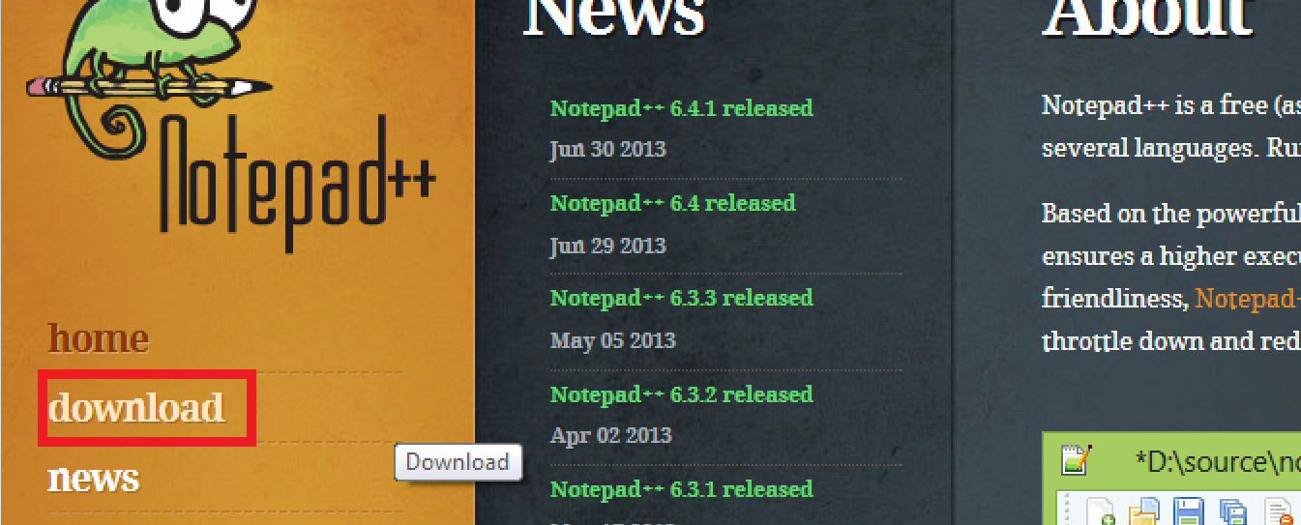
- Click on the download tab on the left side of the page (shown in figure 1.1)
Figure 1.1

- Click on the Notepad++ Installer (Shown in figure 1.2)
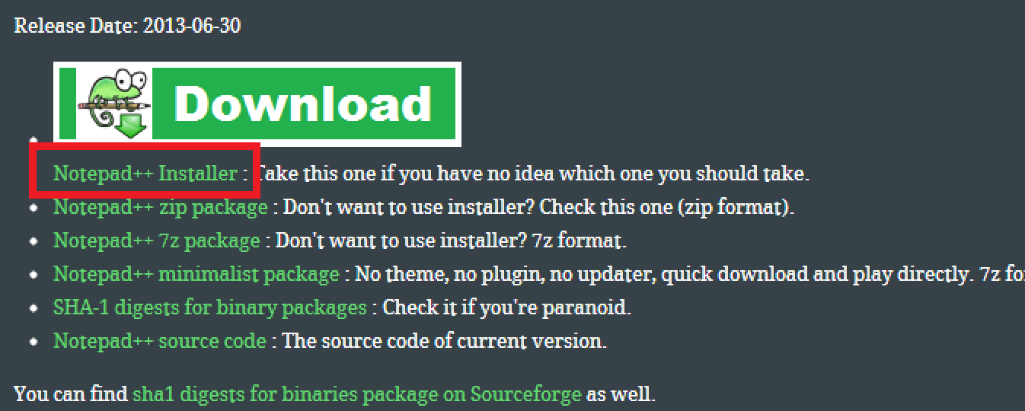
Figure 1.2
- Once the file downloads in your browser click the download to open the installer

Installing Notepad++
  - Select a language from the drop down list (Figure 1.3)
  - Click next
  - Read the license agreement then click “I Agree”
  - Choose the location which you want to place notepad++ then click next
  - Select “custom” (this manual will go over customization later) then click next
  - Check the box that says “Create shortcut on desktop: then click install (Figure 1.4
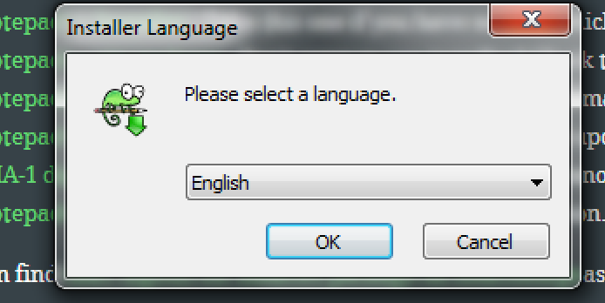
Figure 1.3
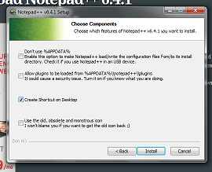
Figure 1.4
Configuration

Choosing a language
- Click on the “languages” tab on the top of the screen
- Select the language you will be using from the drop down list (Figure 1.5)
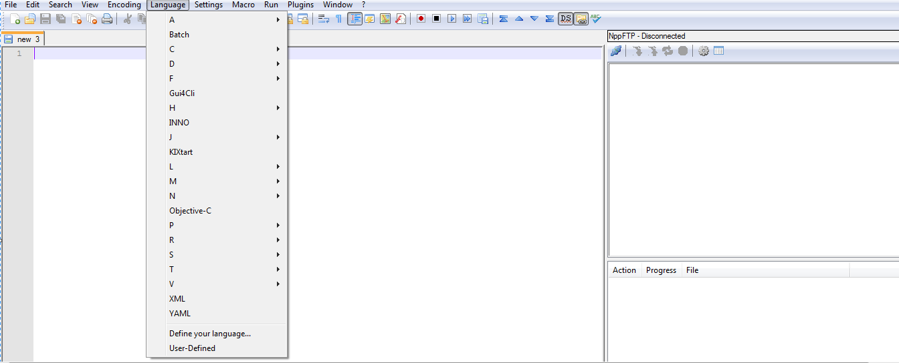

Figure 1.5

Connecting to the CSE machines
The CSE machines at The University of North Texas are Linux based computers that allow students to compile their code for their programming assignments. The instructions on how to connect to the CSE machines follows.
- Click on the “Plugins” tab
- Navigate to the “NppFTP” tab and click “Show NppFTP window” (Shown in figure 1.6)
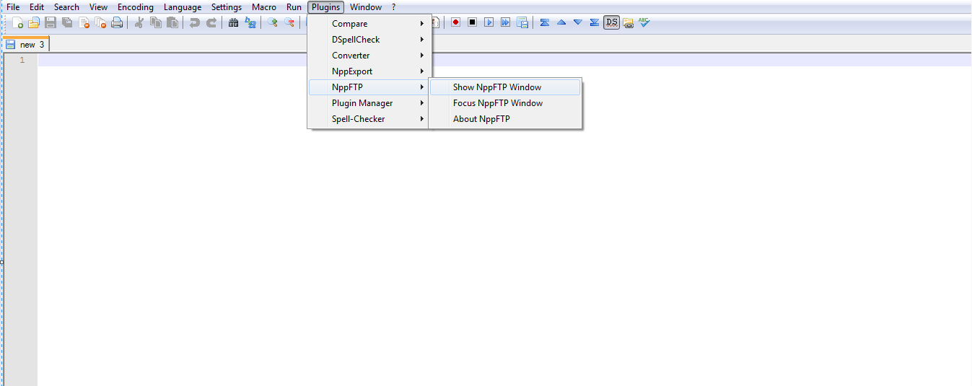
Figure 1.6
- Click on the gear icon on the right side of the NppFTP window
- Click on “Profile Setting” from the drop menu (Figure 1.7)
Figure 1.7
- Input the hostname you wish to connect to (example cse01.cse.unt.edu)
- Enter the password for the entered hostname
- Click “Close” (Profile setting’s window shown in figure 1.8)
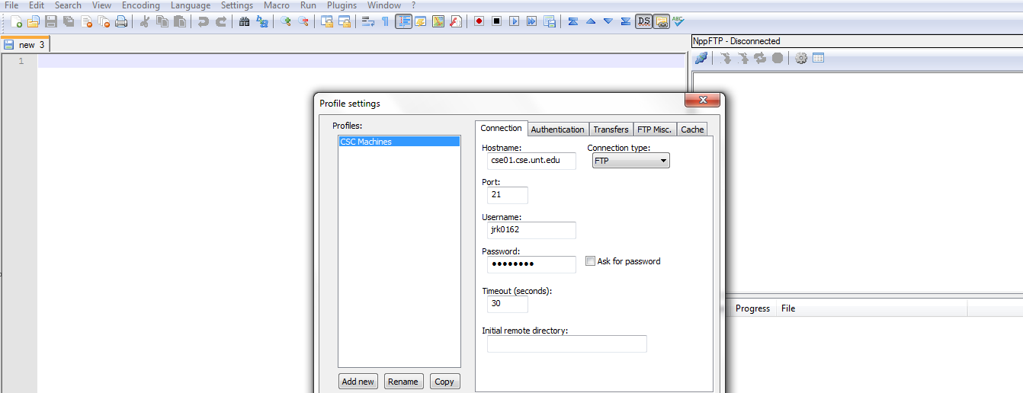
Figure 1.8

- Click on the blue link icon inside of the NppFTP window
- Select the profile you created and it will connect you to the CSE machines

NppFTP File System

The NppFTP is a file system built-in Notepad++ this system allows the user to connect to the UNT CSE machines and enables the user to transfer files back and forth between the user’s computer and the CSE machines. Useful tips on file management with NppFTP is below.

File Management

Uploading file to CSE machine
- Open the NppFTP window
- Click the upload button (Shown in figure 2.1)

Figure 2.1

Note: The file that you are currently working on will upload to the CSE machines.

Creating new file on CSE machine
- Right-click inside of the NppFTP window
- Select “Create new file”

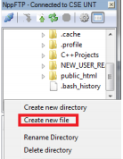

- Enter the directory and name of the file
- Click create

Features and Usage

The features of Notepad++ is what sets it apart from the other source code editors out there. Notepad++ has a vast variety of features that makes programming and debugging code extremely simple. Some useful features and their usage are below.

Multi-editing
- Click on the “Settings” tab at the top of the screen
- Select “Preferences..” from the drop down menu
- Select the “Editing” tab
- Check the box next to “Enable(Ctrl+Mouse click/selection)” (Shown in figure 3.1)
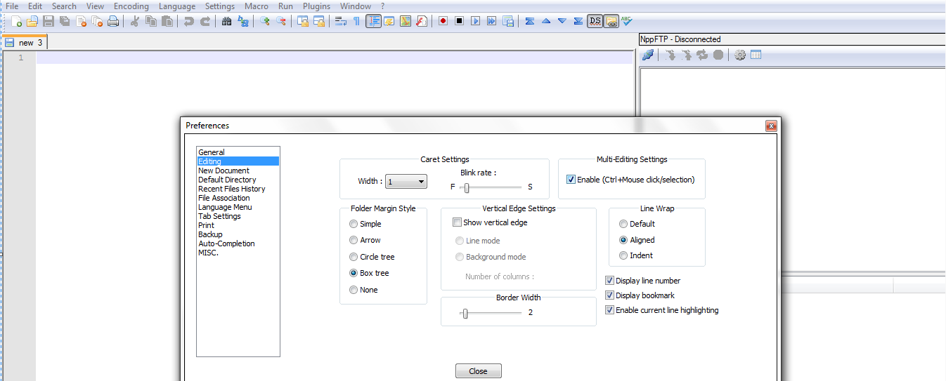
Figure 3.1

Column Mode Editing
- Hold the Alt key
- Drag the mouse down the column you wish to edit

An example of column mode editing is shown in figure 3.2
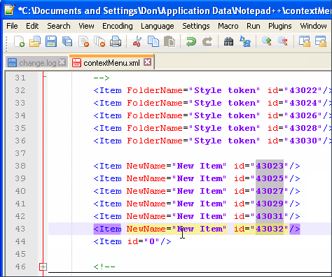
Figure 3.2

Note: Column mode editing will enable the user to change the highlighted selection from figure 3.2 at the same time

Bookmarking
Bookmarking is useful when writing a large program that is difficult to navigate. Bookmarking allows the user to place a bookmark and a specific section of the code and will enable the user to return to the bookmark or flip back and forth through all of the placed bookmarks.
- Press the Ctrl + F2 key on the keyboard to set bookmark on the current line of code
- Press F2 to move forward through the bookmarks
- Press Shift + F2 to move backwards through the bookmarks
An example of bookmarking is shown in figure 3.3

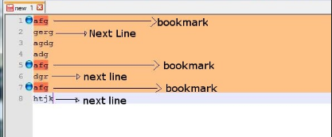
Figure 3.3

Macros
Macro which is short for macroinstruction is a very useful shortcut for computer science majors. Macros allow the user to record a task then the user is able to do that task by simply clicking a button. The instructions on how to record a macro in Notepad++ is below.
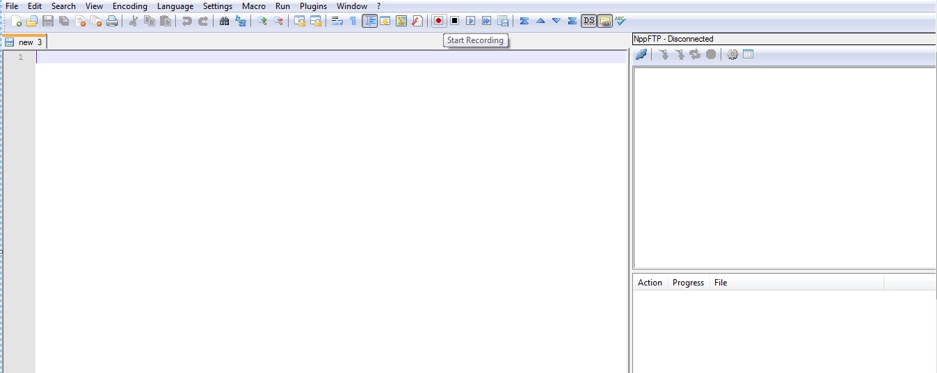
- Click the record button at the top of the screen (Shown in figure 3.4)
Figure 3.4

- Type the task for the macro to perform
- Click the stop button next to the record
- Press play when the task is needed to be performed

Note: The task will be performed at the cursors current location.

Document Map
When writing large programs sometimes it can seem difficult to locate specific sections of code. The document map feature in Notepad++ helps the user by showing the entire program on the right side of the screen and highlighting the section that the user is currently viewing. The instructions on how to display the document map in Notepad++ follows.
- Click the view tab at the top of the screen
- Select “Document Map” from the dropdown menu
The document map view is shown in figure 3.5

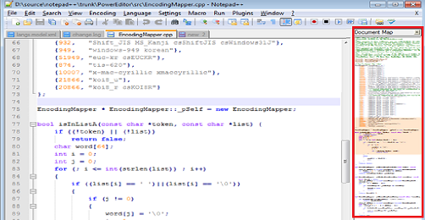
Figure 3.5

Function List
The function list feature in notepad++ shows the user all of the created functions in a program and displays them on the right side of the screen for easy navigation. The instructions for how to enable the function list in notepad++ is listed below
- Click the view tab at the top of the screen
- Press “function list”
The function list view is shown in figure 3.6
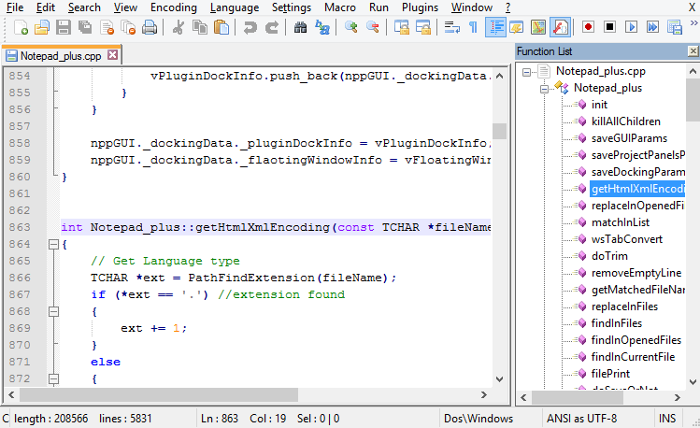
Figure 3.6

File Comparison
File comparison is used to compare two or more computer files finding the similarities or the differences. This feature is useful for computer science majors to compare their written code to already established working code and check out the differences. Steps on how to compare files in Notepad++ are below.
- Open up two files that are being compared in Notepad++
- Click Plugins at the top of the screen
- Click on the compare button
The two files will show up side by side and the user will be able to spot the differences.
An example of a file comparison is shown in figure 3.7
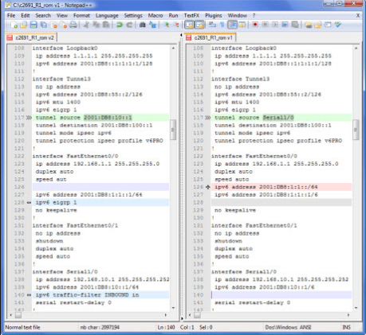
Figure 3.7
Speech Synthesis
A great feature in notepad++ is speech synthesis which allows the user’s computer to dictate the written code. This feature is especially important to students with disabilities. The steps to activate speech synthesis in notepad++ is below.
- Click the view tab at the top of the screen
- Click the speech settings button on the drop down menu
- Press the “Start text-to-speech” button on the right of the window

Find and Replace
The find and replace feature in Notepad++ allows the user to find every instance of a certain text and change each instance simultaneously. The steps on how to find and replace in notepad++ are below.
- Press (Ctrl + F)
- Enter the text to find
- Enter the replacement text
- Click “Replace all”
An example of the find and replace window in Notepad++ is shown in figure 3.8
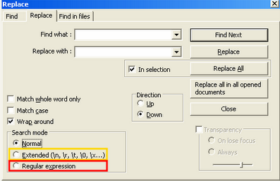
Figure 3.9

GUI Customization
A great feature in Notepad++ is the ability to personalize the theme and layout to fit the user’s style. Some useful instructions on how to personalize notepad++ follows.
Themes
If the user does not want to customize each element for their own theme there is several options of built-in themes that the user can use. Instructions on how to change the theme of Notepad++ is below.
- Click the settings tab at the top of the screen (shown in figure 3.9)
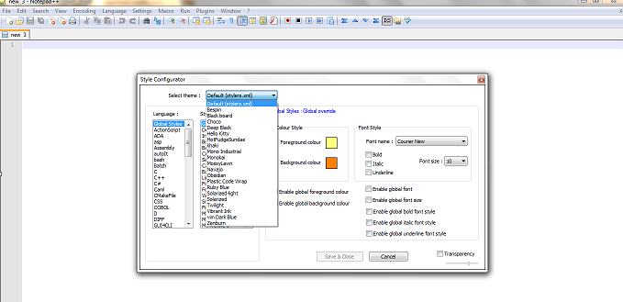Figure 3.10
- Select “Style Configurator” from the drop down menu
- Click the down arrow where it says “Select theme” (Shown in figure 3.10)
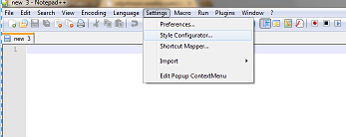
Figure 3.11
- Select the theme to use

Changing Fonts
- Click the settings tab at the top of the screen
- Select “style configurator” from the drop down menu
- Click the down arrow next to “Fonts” (Shown in figure 3.11)
- Select the font
- Click “Save and Close”

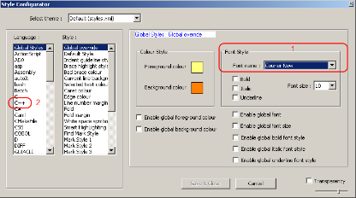
Figure 3.11

Index

Customization, 24
editing, 3, 15, 16
Features, iii, 15
File, iii, 11, 21
function, 20
instructions, 3, 7, 18, 19, 20, 24
NppFTP, iii, 7, 8, 11, 12
Settings, 15

